

Custom Java Application Case Study
An Example of Alternate UI for ECL

Overview

The Emergency Contact List (ECL) is a sample BlackBerry application that demonstrates how to easily push key data, contained within any type of database, to BlackBerry users. The data can be pushed to the BlackBerry Browser, using the channel push mechanism, or to a custom java catcher application on the handheld.

The customer catcher java application included with the ECL sample provides additional control over usability and data storage over the browser. The catcher is purposefully simple and generic, so that it can be used to display different types of data, for different use cases. Developers are encouraged to re-use, or extend this sample to meet their own needs.

The following case study provides an example of how an entirely new user interface can be easily developed to present the push data within the ECL custom catcher, without making changes to the data itself. This ‘MulitpleScreen’ UI, can be used with the existing ECL sample, and is also free to be re-used and extended.

Installation and Testing

Step 1: Using the BlackBerry JDE open up the ECLContactList.jdw workspace located under: [com\rim\application\samples\MultipleScreen\ECLContactList.jdw].

Step 2: For testing purposes run the application by pressing F5. This will open up the MDS simulator and the Device simulator. If you want the catcher to be loaded up on your device, the ECLContactList.alx can be found under [com\rim\application\samples\MultipleScreen\bin\ ECLContactList.alx].

Step 3: Select the desired sample database as the content to send to the device, which is found under your installed version of ECL server side (can be .NET, Java or Domino.) Make sure you are pushing to the custom catcher and not to the browser. Please refer to your user guide to get more information on your specific ECL version.

Step 5: If all information is correct the push should be successful.

UI Components

You should be able to make any change to the look-and-feel of the device app by touching only the code in ECLApplication.java. The code in PushedDataListener.java is a fairly generic push listener, while src\DataStore.java deals with lower-level data management.

The new custom catcher removed the tree list field and separated it into three different screens. Looking at Figure #1 the previous custom catcher had one screen, which included the tree list field to show all contact information. Figure #2, 3, 4 shows how the new custom catcher with the first screen having a list of Groups, the second screen showing the contacts name and the last screen showing their information. Also notice in the last screen the phone and e-mail content are underlined. This entails they are active field, hence Figure #4 shows from the menu we can directly call or e-mail them.

All of the UI changes were made were to the ECLApplicaiton.java. For adding a notification profile, that code was added to the PushedDataListener, since we want to immediately notify the user new content has arrived. A minor change was made to DataStore, since a Vector is a RIM class which means that when the application is removed we don't know that the PersistentObject should be removed because it could be used by another application on the handheld (interprocess communication). To ensure that your PersistentObject is removed when the application is removed we have to:

- Create your own "version" of Vector by extending it and defining that class in your package.
- Set the contents using your own Vector.

This why the class eclStore.java exists, to make sure when the application is deleted, all of its content is also deleted.

Since there was more than one screen in the new catcher, there were three different classes made, rather than one. This really simplified the development for the new catcher. Also note from Figure #3 there is a FIND field provided, which is its own class.

The new catcher incorporates an ObjectListField object so it can be selected, filtered and be scrollable. Therefore screen 1 and 2 are both OjbectListField, while the last screen is all ActiveRichTextField. It is because of this ActiveRichTextField that BlackBerry recognizes a phone number or an e-mail address. This is why the automated menu is populated, when an appropriate ActiveRichTextField is selected. To see more detailed information on these objects please refer to the JDE API.

The “Add Contact” (figure #3) functionality found on the second screen is using the “AddContact” class which is the following API:

- javax.microedition.pim
- net.rim.blackberry.api.pdap

These APIs allow the creation of a contact, update any of its field and store it on the device’s address book. This is the only class that is customized for ECL but it samples the simplicity and ease of use to integrate with other applications.

One can make any changes they like to the custom catcher and they will be able to run the result in the simulator. When you want to deploy your modifications on a real device, your compiled code needs to be signed since it uses RIM's persistence and networking APIs.

New Additional Features:

- Provides a search capability
- Easing the usability by having the users selected from a BES list rather providing a user.txt
- Includes a notification profiler, now when new content is sent to the device, the user can be notified. The type of notification can be set under their Profiles/ECL.
- Integration with Address book
- Auto generated menu items for an active field

Future Considerations

ECL is one of the highlight samples for the BSG and many cliental are further developing around the ECL for their environment. ECL at the BSG level will continue to grow and here are some insights to what the future holds for ECL.

- Enabling a user to make changes to the data, synchronizing with back end database and pushing the auto update to all ECL users
- Integrate core applications
- Using different data formats, such as XML
- Integrating Wireless Binary XML (WBXML) with ECL for a more efficient and quick data transfer
- Introduction of a more dynamic design for the custom catcher, where news break can be seen

Appendix

FIGURE#1: Tree List UI FIGURE#2: 1ST Screen of the Alternate UI
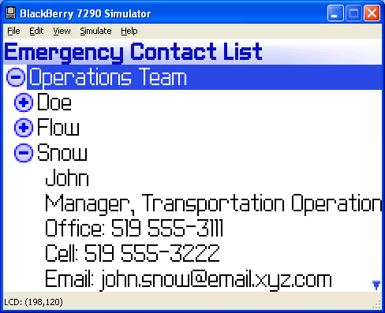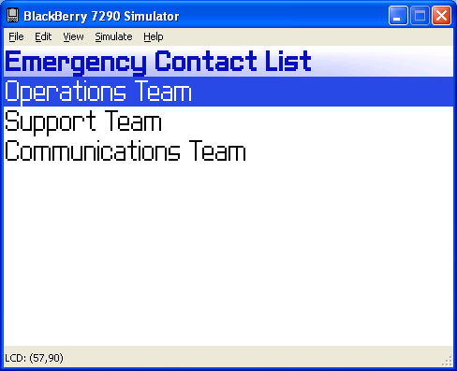

FIGURE#3: 2nd Screen with Find FIGURE#4: Last Screen with
Function ActiveRichTextField
